## **EXPERIMENT 4**

## **Objectives**

* Explain how to resolve the conflict during merge.

In this hands-on lab, you will learn how to:

* Implement conflict resolution when multiple users are updating the trunk (or master) in such a way that it results into a conflict with the branch’s modification.

## **Prerequisites**

The following are the pre-requisites to complete this hands-on lab:

* Hands-on ID: **“Git-T03-HOL_001”**

Estimated time to complete this lab: **30 minutes.**

Please follow the instructions to complete the hands-on. Each instruction expect a command for the Git Bash.

* Verify if master is in clean state.

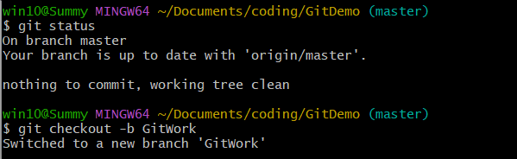

* Create a branch **“GitWork”.** Add a file “hello.xml”.



* Update the content of “hello.xml” and observe the status

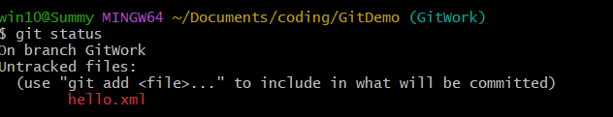

* Commit the changes to reflect in the branch

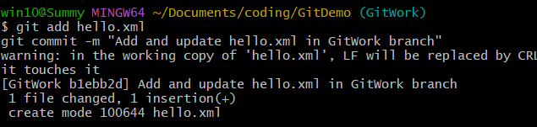

* Switch to master.

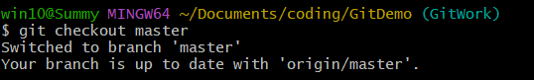

* Add a file **“hello.xml”** to the master and add some different content than previous.



* Commit the changes to the master

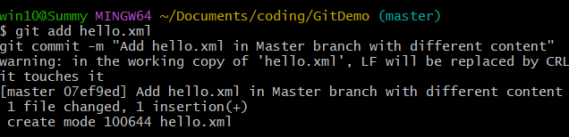

* Observe the log by executing **“git log –online –graph –decorate –all”**

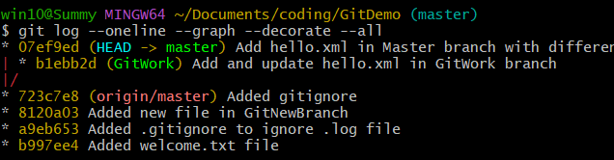

* Check the differences with Git diff tool

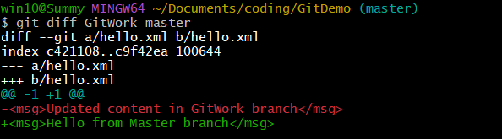

* For better visualization, use P4Merge tool to list out all the differences between master and branch



* Merge the bran to the master

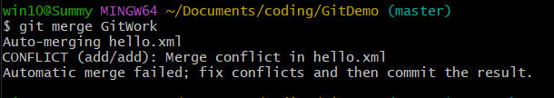

* Observe the git mark up.

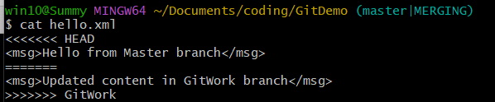

* Use 3-way merge tool to resolve the conflict

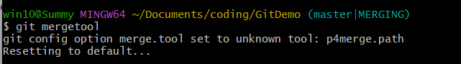

* Commit the changes to the master, once done with conflict

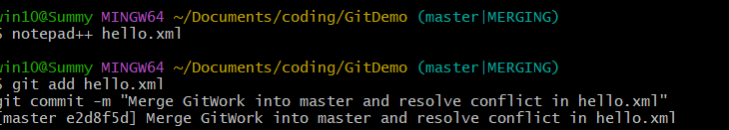

* Observe the git status and add backup file to the .gitignore file.

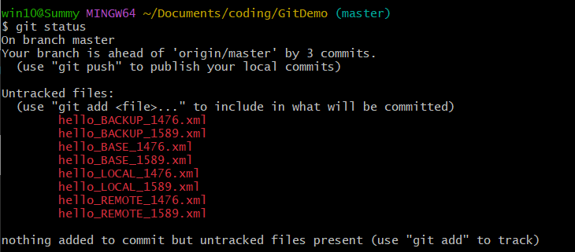

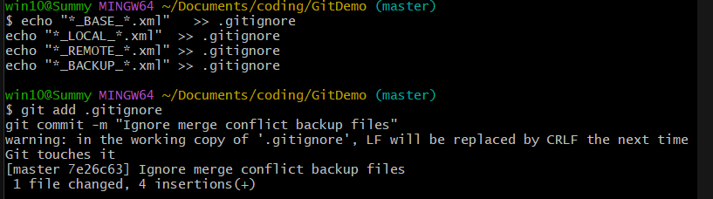

* Commit the changes to the .gitignore

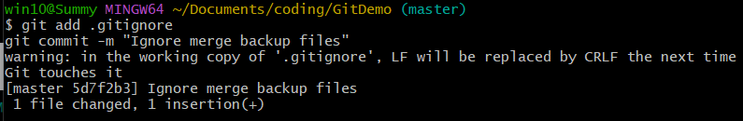

* List out all the available branches

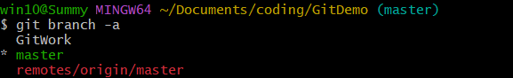

* Delete the branch, which merge to master.

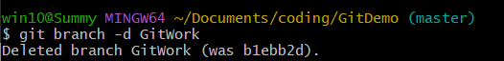

* Observe the log by executing **“git log –oneline –graph –decorate”**

